Name: _Nicholas M. Schmitz  
Date: 2/8/2014

1. What is good and bad about RAM as storage for the operating system and data? – 2pts

RAM is much faster so operations can complete quicker without need for loading off the hard disk. It’s bad as storage because it is volatile and there is a limited amount the operating system can use. It is also harder to manage than disk storage. Limited RAM may require use of a swap file.

1. As you increase the number of processors by N, is the speedup ratio also N? Why or why not? – 2pts

The speedup will be slightly slower than N because there needs to be a slight overhead for process timing/syncing between the two processors.

1. What could you use a cluster for? – 1pt

You could use cluster software for FTP sites managing files being downloaded, or massive SQL database query machines. Anything that needs to be searched, sorted, and displayed the more processors working on that task the better ☺

1. Where would you store a small amount of data, say a 32 bit integer – on the heap or stack? Why? – 1pt

I would store that in the stack because it is opened at process start and you don’t need as much room as what a heap can offer. It will also open faster than the heap.

1. Where would you store a large data structure (32MB+) on the heap or stack? Why? – 1pt

I would store this in the heap so that more memory can be allocated for it without having to worry about the stack closing it properly

1. Please fill in the blanks that describe the migration of integer A from disk to register (hint-pg 28): - 1pt

**Magnetic disk**

**C?**

**B?**

**A?**

A: __Main memory

B: _Cache

C: _Hardware Register

1. Please write an application (language of your choice but they MUST use system calls) that moves a file (ie implements mv command) in the platform of your choice (Windows or Linux).
2. #include <stdlib.h>
3. #include <string>
4. #include <iostream>
5. using namespace std;
6. int main()
7. {
8. string file1, file2;
9. cout << "What is the name of file1?" << endl;
10. cin >> file1;
11. cout << "What is the name of file2?" << endl;
12. cin >> file2;
13. string call = "copy C:\\" + file1 + " C:\\" + file2 + " /Y";
14. const char * i = call.c_str();
15. system("cd c:\\");
16. system(i);
17. string del = "del C:\\" + file1 + " /q";
18. const char * d = del.c_str();
19. system(d);
20. return 0;
21. }
22. Please write an API that wraps the code for the cp command such that the function has a prototype of: - 3pts

void cp(const char * src, const char * dst)

Hint 1: It’s simpler than you think

Hint 2: Look at the sample code

1. What benefits are there to a micro-kernel? What benefits are there to a monolithic kernel? Which would you use and why? -2pts

The micro-kernel provides more security and reliability to the user since most services run as the “user” and not “root”.

Monolithic kernels are usually faster for processing.

1. At what level ring/layer allows full unrestricted access to the hardware? – 1pt

Ring 0 allows the most access to the hardware.

1. Name 3 tools from either Windows or Linux that allow you to inspect system information and state what information they show. – 2pts

Windows- dxdiag: allows for expanded information on graphics hardware

Windows- system information: Allows you to browse information about hardware installed and the operating sytem.

Windows- Event Viewer: Able to see events and other flags that software/hardware gives to the operating system. Handy for debugging system problems.

Windows- Task Manager: find processes, applications, services that are running and the amount of resources in use by each. (leads to new resource monitor in winVista and later for more thorough thread examination etc etc).

Extra credit:

1. In class we discussed two modern ways that people interact with the operating system (CLI/Shell and GUI). Today we interact with these interfaces, usually, with a keyboard and mouse. What other way(s) could one interact with the operating system? (Hint: It’s currently being researched/developed and Microsoft has their own concept(s):

<http://www.youtube.com/watch?v=a6cNdhOKwi0> ) – 2pts

Virtual reality systems are going to be A HUGE step up for interfacing with computers. This will enable programs especially ones heavily relying on display such as solidworks, cad etc, to be worked on in a much quicker more flexible way than the typical click/double click/right click fashion. I am also becoming more and more interested in speaking commands which has made leaps on the mobile field but has not gone as mainstream on the PC end.

1. In the git repo I provide sample code from MikeOS (<http://mikeos.sourceforge.net/write-your-own-os.html> ). After you use the provided scripts to download the necessary tools to work with this code, the assignment is to see if you can add some color to the output. ie turn this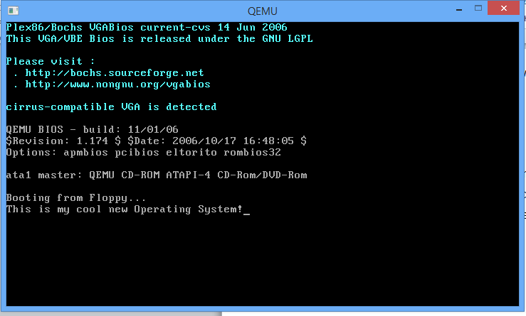  
   To this (be creative!): - 4pts 